**TOWER DEFENSE**

**PROJECT PLAN AND UMBRELLA ACTIVITIES**

Team Organizational Chart

* **Daniel** - Lead Project Designer/Programmer
  + Taking the role of leader in a Centralized Democratic System, Daniel will work with the other members to delegate tasks. He will also lead in the design and implementation of the project, while taking a hand in programming tasks.
* **Jake** - Programmer and Tester
  + Jake will take a heavy role in programming different functions into the program and test all interactions in the video game to ensure their validity.
* **Nick** - Lead Documenter and Tester
  + Nick will take responsibility for most documentation tasks surrounding the project. He will also ensure all code is properly commented to ensure the functions are understood. He will also help in the testing of the program.

Gantt Chart

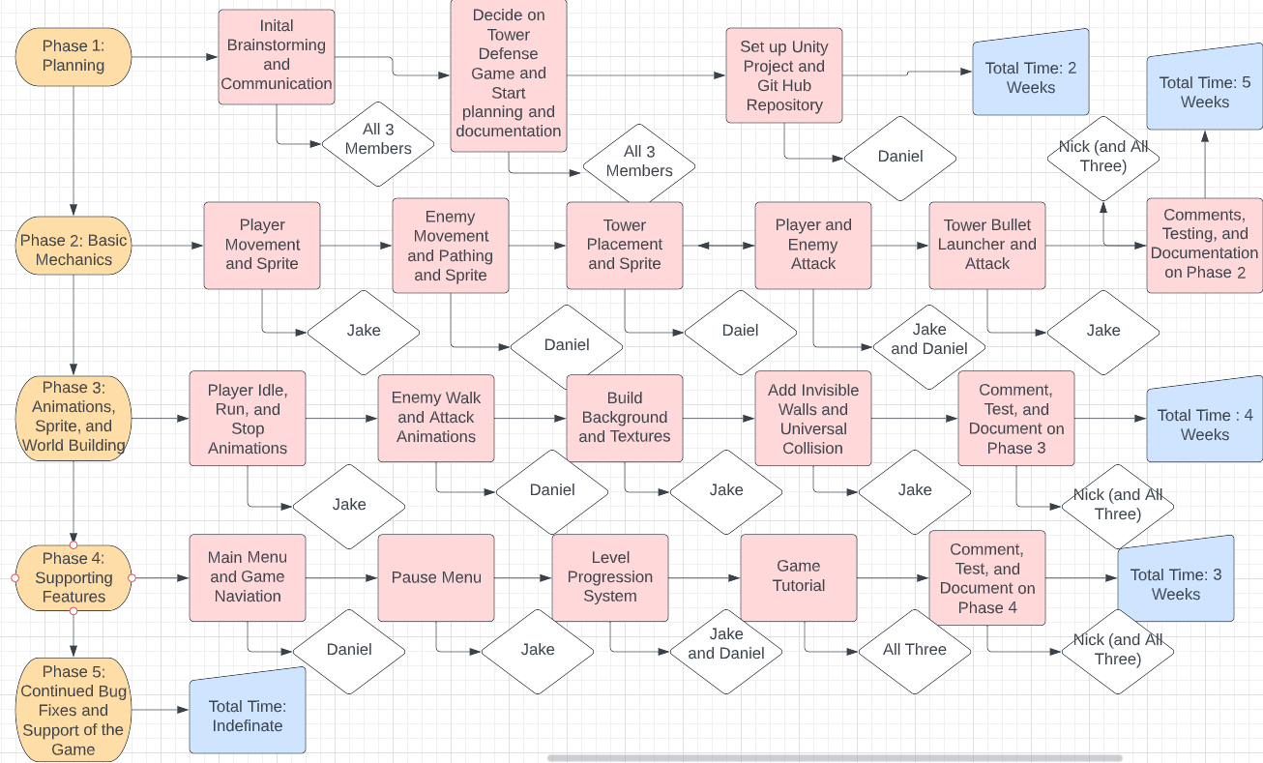

Tools and Standards

* Tools
  + The Unity Game Engine
  + Github (Web servers and desktop app)
  + C#
  + Visual Studio
* Standards
  + Following Unity Standards for code style
    - Brackets get own line
    - Variables use camel case
    - Declaring variables with level modifiers
    - Using multiple scripts for different functions and classes
    - Putting classes into Unity prefabs for multi use
  + Documentation Standards
    - Using descriptive names for scripts, classes, variables, and methods
    - Commenting the function of blocks of code, unless very easily understood and short